<http://www.solvobiotech.com/images/uploads/Enterocytes1.jpg>

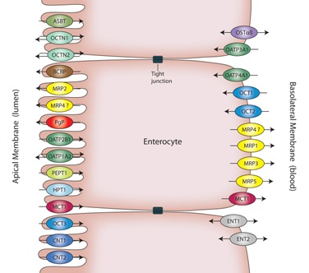

<http://img.thebody.com/legacyAssets/08/75/abcs_figure1.jpg>

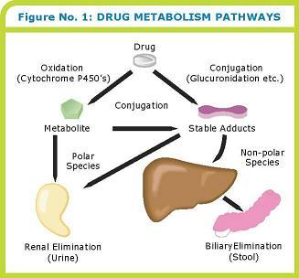

<http://nursingpharmacology.info/General/Pharmacokinetics/diffusionmedium.jpg>

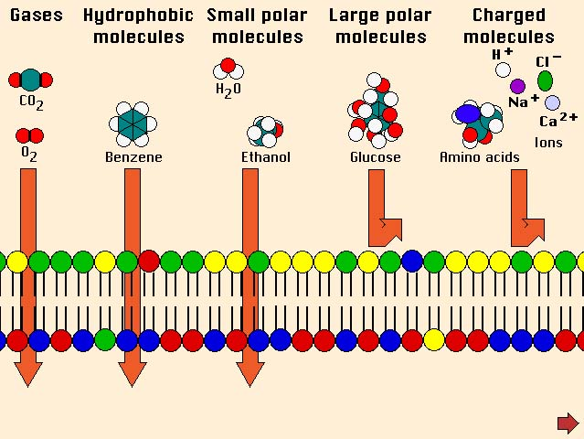

<http://pharmaxchange.info/press/wp-content/uploads/2011/04/06.jpg>

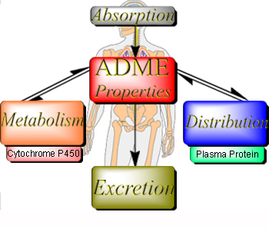

<http://howmed.net/wp-content/uploads/2011/08/factors-affecting-absorption-of-drugs1.png>

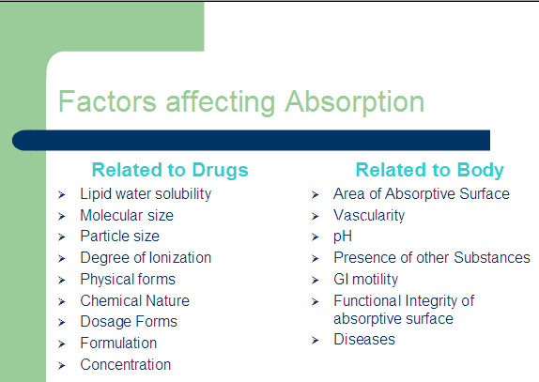

http://www.doctorfungus.org/thedrugs/images/antifung_1.jpg

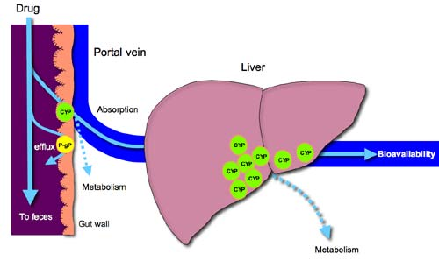

https://o.quizlet.com/i/ZfKbIDUW0AbVVEH4_97uOg.jpg

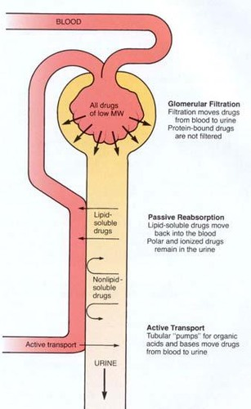

<http://intranet.tdmu.edu.ua/data/kafedra/internal/magistr/classes_stud/English/First%20year/Clinical%20Pharmacology/01_Clinical%20pharmacokynetic_pharmacodynamic.files/image017.jpg>

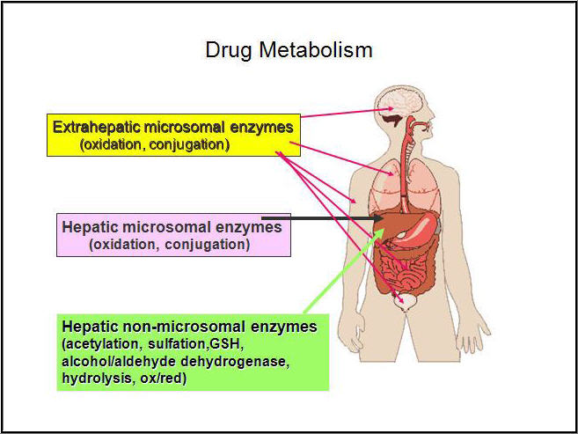

<http://dualibra.com/wp-content/uploads/2012/04/037800~1/Part%201.%20Introduction%20to%20Clinical%20Medicine/005_files/loadBinary_003.gif>

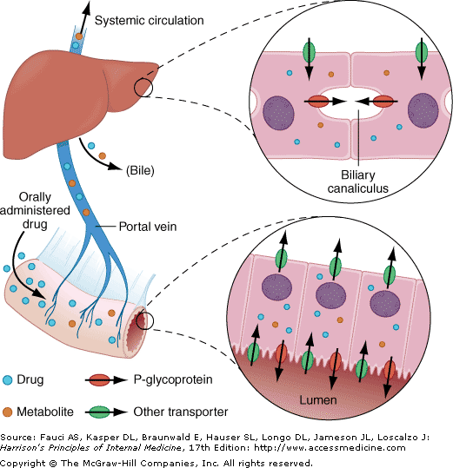

<http://www.nature.com/nrd/journal/v2/n3/images/nrd1032-i1.gif>

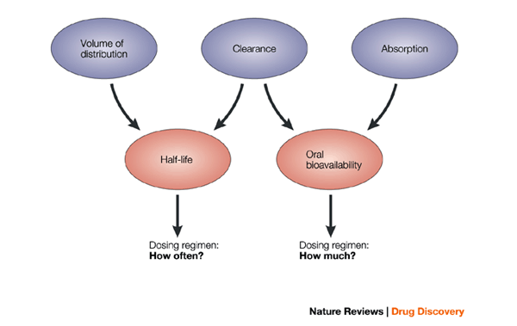

<http://intranet.tdmu.edu.ua/data/kafedra/internal/klinpharm/classes_stud/en/pharm/prov_pharm/ptn/Factors%20and%20mechanisms%20of%20pharmacological%20activity/3/Practical%20Class_3.files/image003.gif>

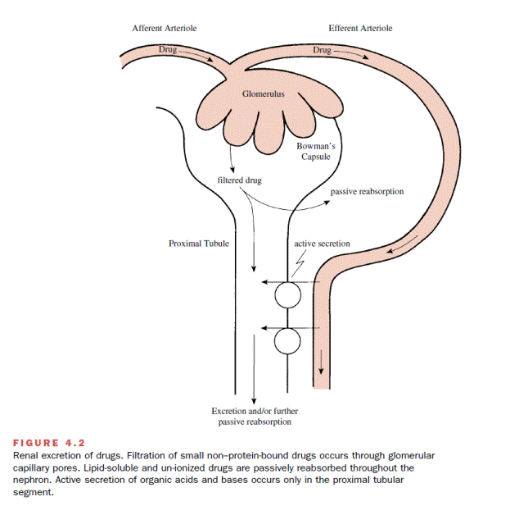

<http://pharmafactz.com/wp/wp-content/uploads/2014/12/active-transport.jpg>

